Painting Process: Flowers

1. This is the initial sketch on the painting panel. You’ll notice that I’m using a panel that had already been painted on. In order to have a consistent surface texture, I sand off the original layer. Because the background will be painted very dark, I used a red paint that will allow me to easily see the shapes of the flowers, leaves and stems. This initial sketch is quite loose and through most of the next steps, the drawing will be refined. For this step I use a small filbert hog bristle brush.

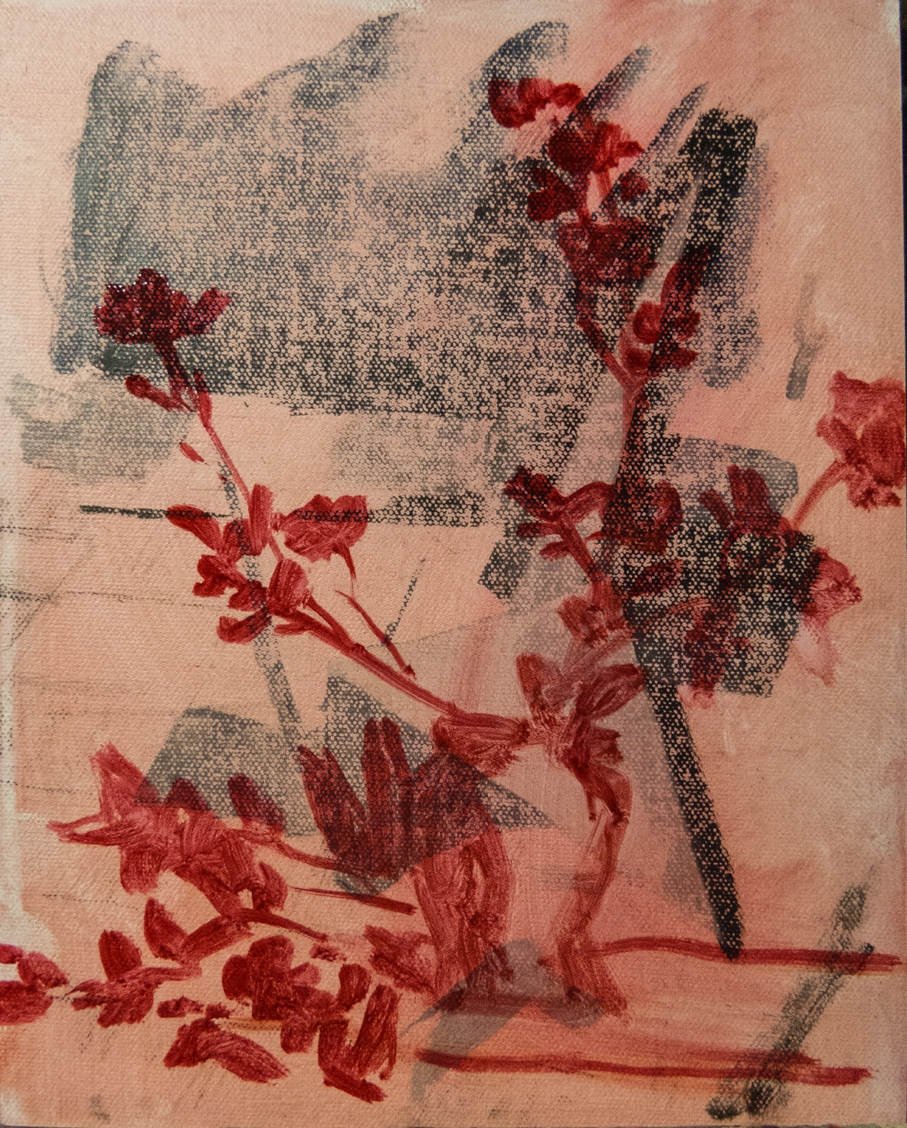
2. This is a critical step; it establishes the major value masses: the darkest dark of the background, shadow side of the vase, and the leaves in shadow; the middle value that will eventually become the greens of the stems and leaves, and the shadow side of the flowers; finally, the lights—the light side of the vase, the table top and the clothe (as you can see, I toned the panel surface with a light red oil wash before I began my painting). These large masses are best painted using hog bristle flats and Utrecht Tuscan Series 206-F brushes and sables.

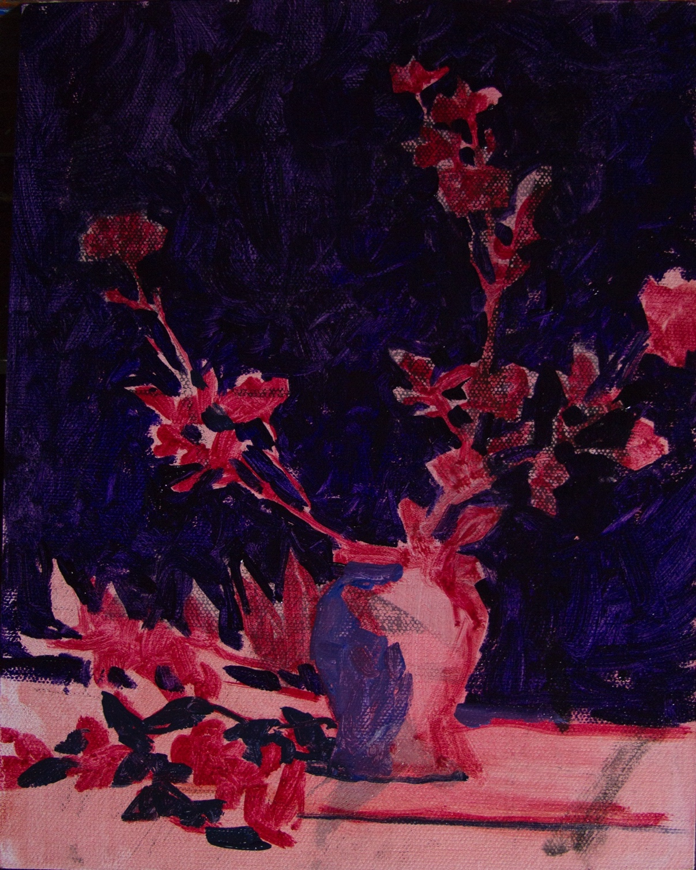
3. While generally maintaining the value masses, I added appropriate colors—greens to stems and leaves, warm greens in the light and cool dark green in the shadow; light warm reds to the light side of the flowers, warm ochres to the table top and warm whites to the fabric. This subject is composed of small shapes and fine lines, therefore, red sables or black sables are best suited, though, because they are great shape making tools, I like to use Utrecht Tuscan Series 206-F brushes as much as I can (I use these brushes for the leaves and the light areas of the flowers).

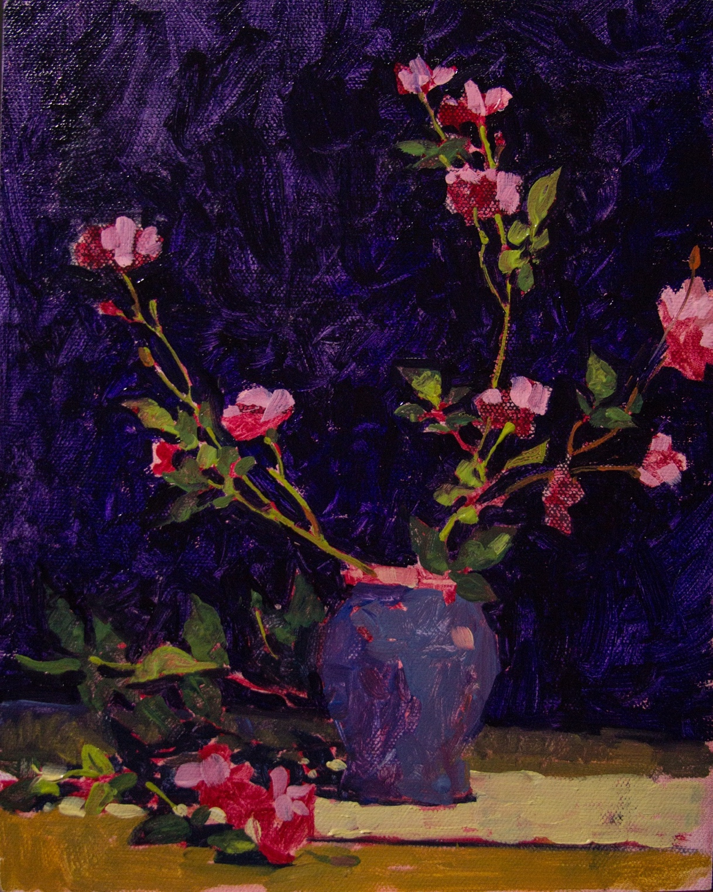

4. Finish. Typically, the previous steps take very little time, while finishing requires the bulk of my effort. Finishing entails the resolution of myriad details. Shapes are refined, values heightened or lowered, and color temperatures adjusted, etc. I repainted the background as I finished this painting and returned to hog bristle and Utrecht Tuscan Series 206-F brushes, but all the smaller areas were painted with flat black sables and round red sable brushes.

